Theory of Action—State Examples
ESEA Flexibility Principle 3 Toolkit
Version 1.0 — January 3, 2012

Compiled by West Wind Education Policy Inc.

This document provides a space for states to share with one another the ways they are conceptualizing, designing, and implementing their systems of evaluation and support. Version 1.0 of this resource focuses on graphical representations; the next version will add information from Flexibility applications.

The following examples have either been contributed directly from SCEE members or pulled from state websites and Race to the Top applications.

Your colleagues want more examples!

Upload examples of your systems of evaluation to http://scee.groupsite.com/file_cabinet/index/199251 and email circe@westwinded.com to let us know you have shared information.

Graphical Representations of the Broader System of Education

Several states have designed graphical representations of the system of education in their applications for Race to the Top (RTTT). While those applications focus on the four pillars within RTTT, the same idea can hold true for the applications for ESEA Flexibility—demonstrate graphically how all the Principles within the Flexibility Request fit together to improve student achievement.

Delaware

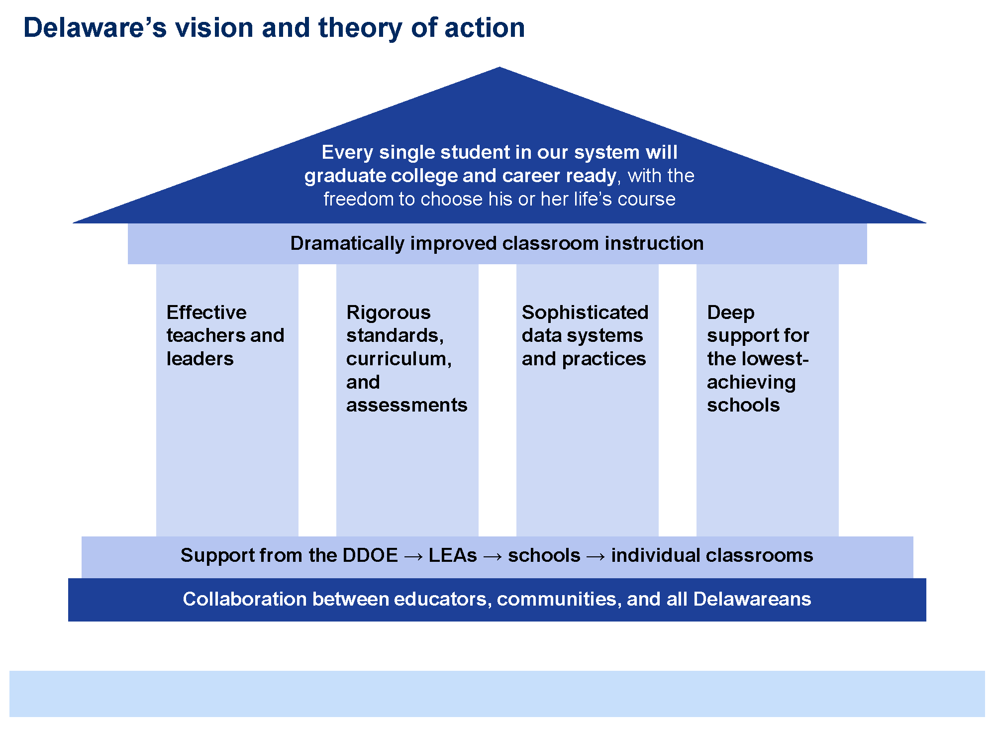

Rhode Island
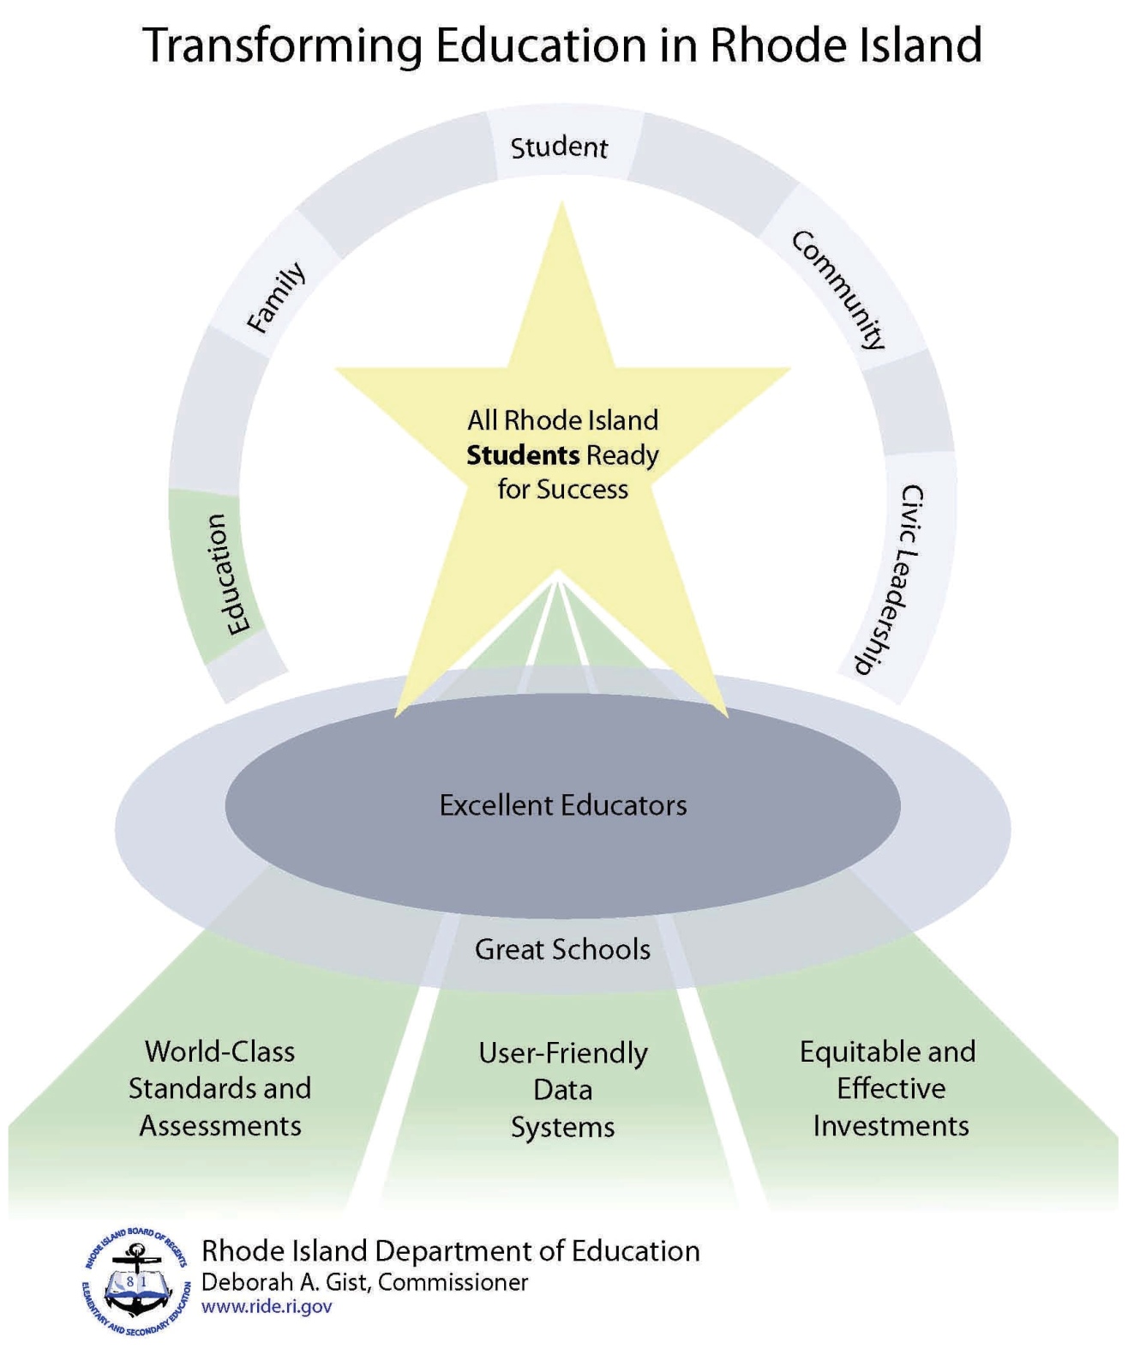

Graphical Representations of Educator Effectiveness Systems

Graphical representations of the state system of evaluation and support/educator effectiveness also are helpful. Different aspects needing explanation include the career continuum, the systems of evaluation and support, and components with the system of evaluation and support.

Alabama
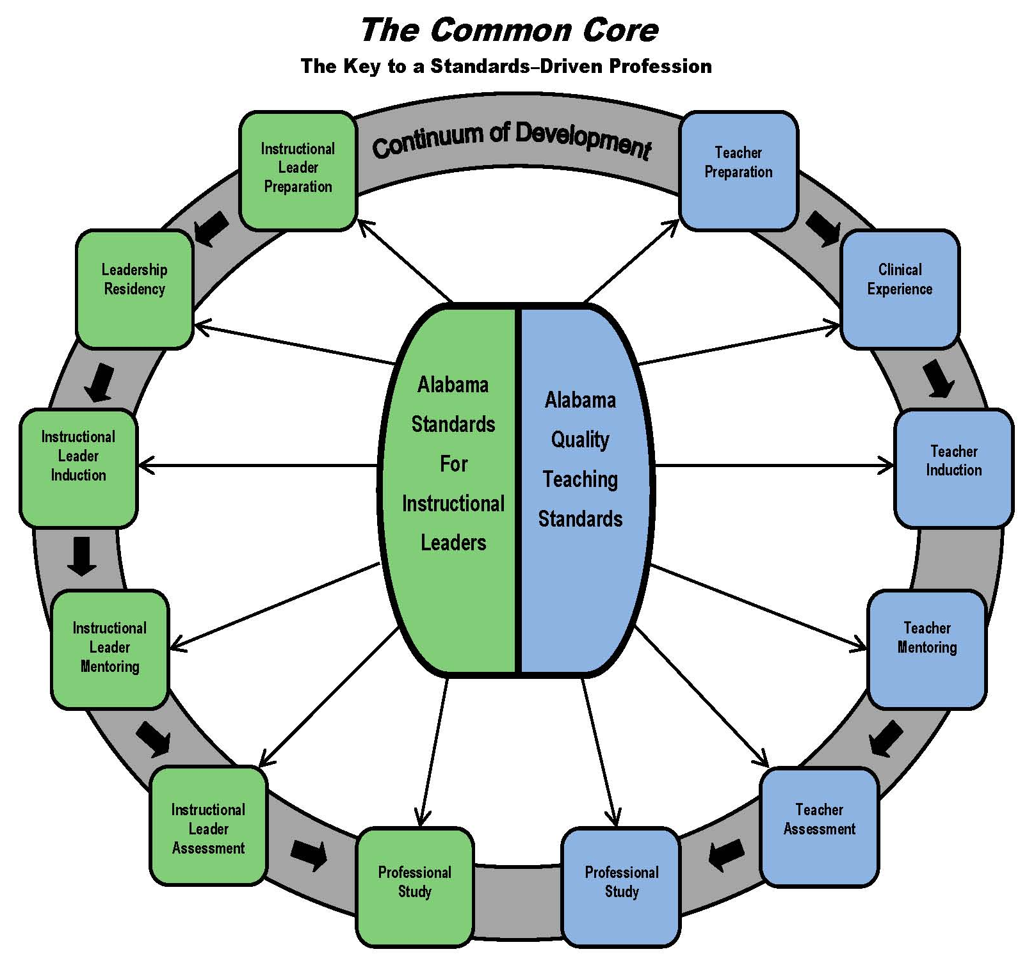

Ohio

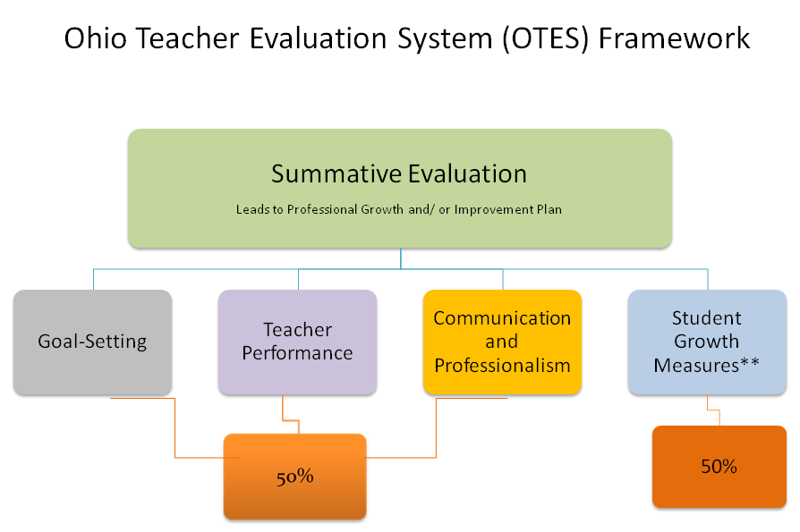

Utah

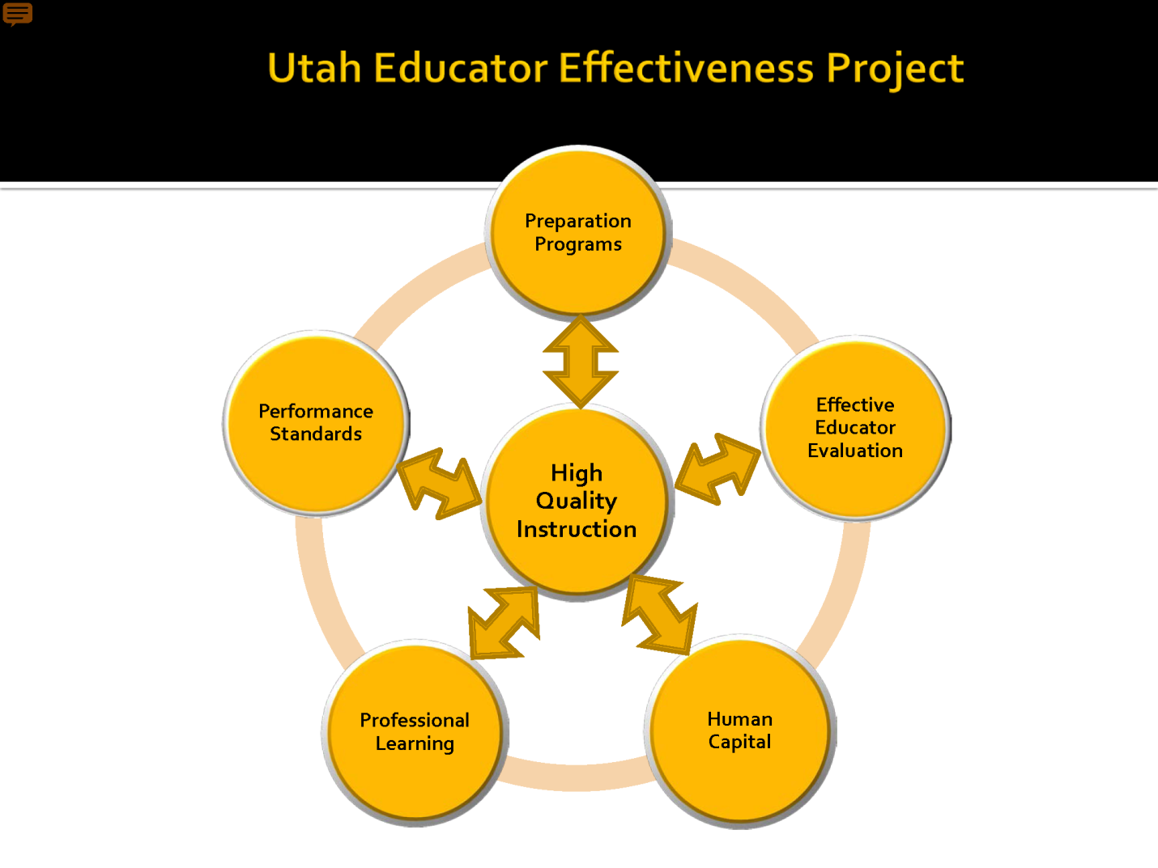
Wisconsin

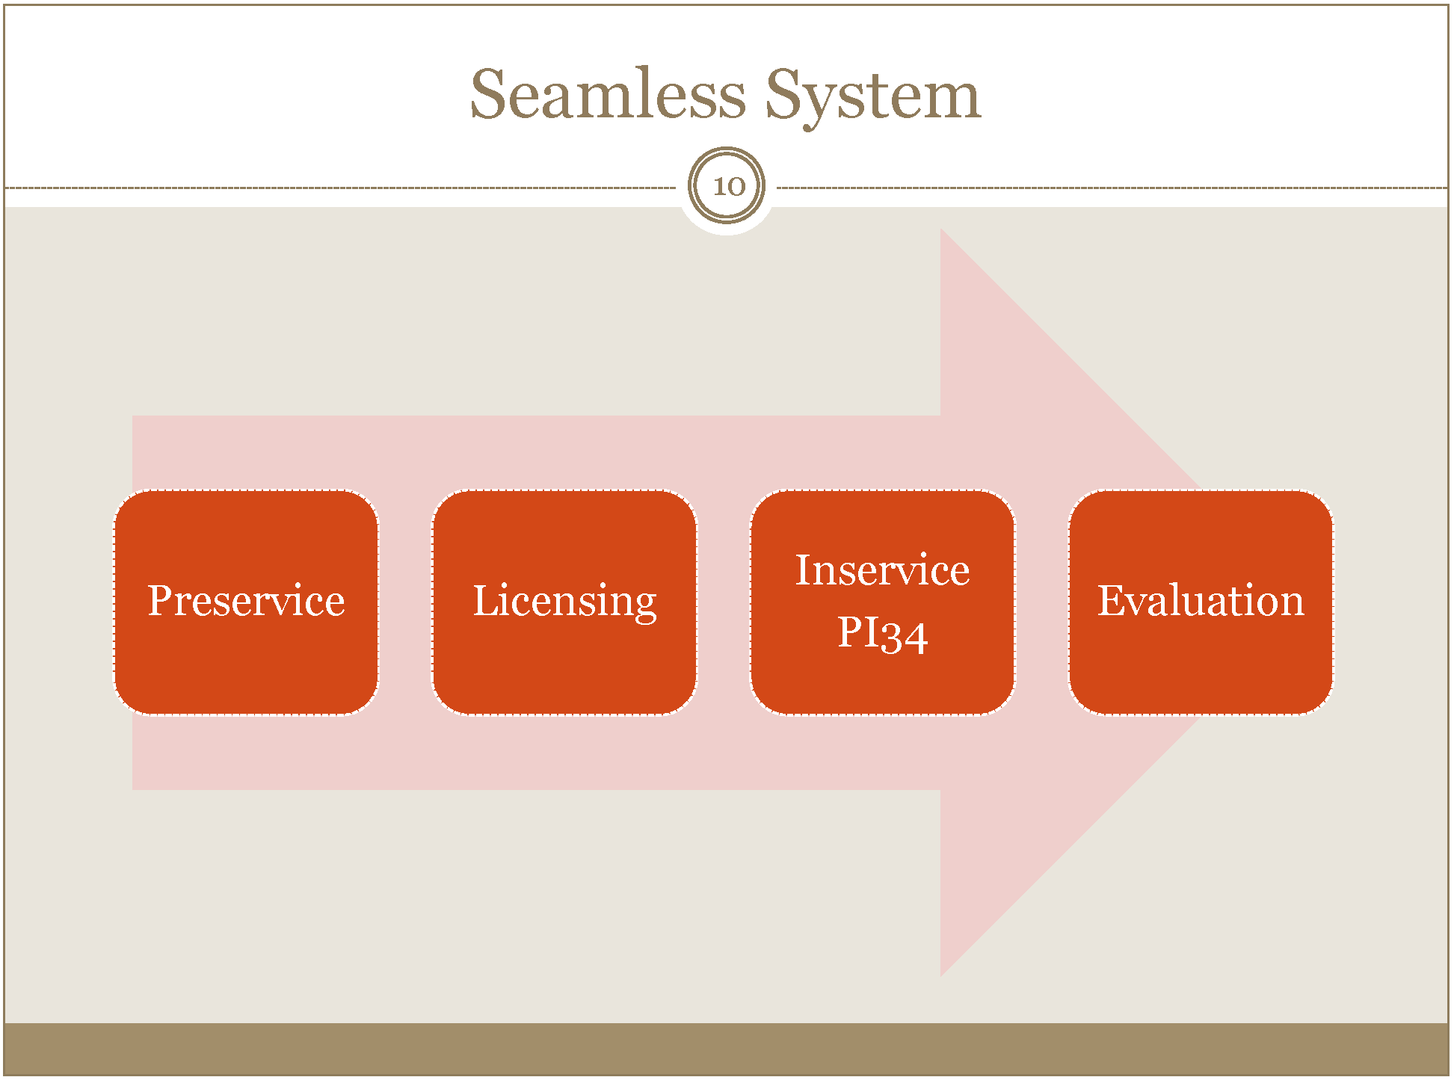

Other Examples

CCSSO’s State Consortium on Educator Effectiveness (SCEE)

SCEE’s representation of state policies impacting the education workforce

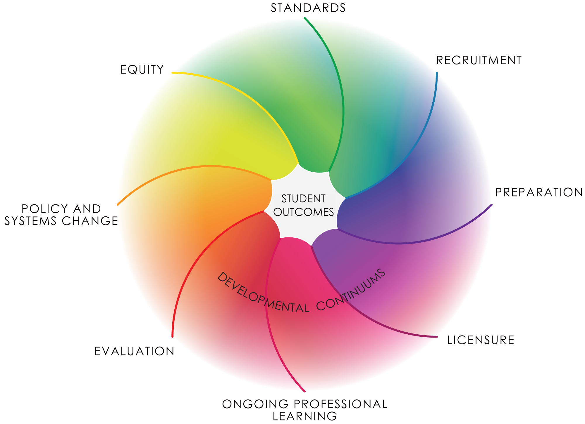

CCSSO’s representation of the relationship among state policies impacting the education workforce

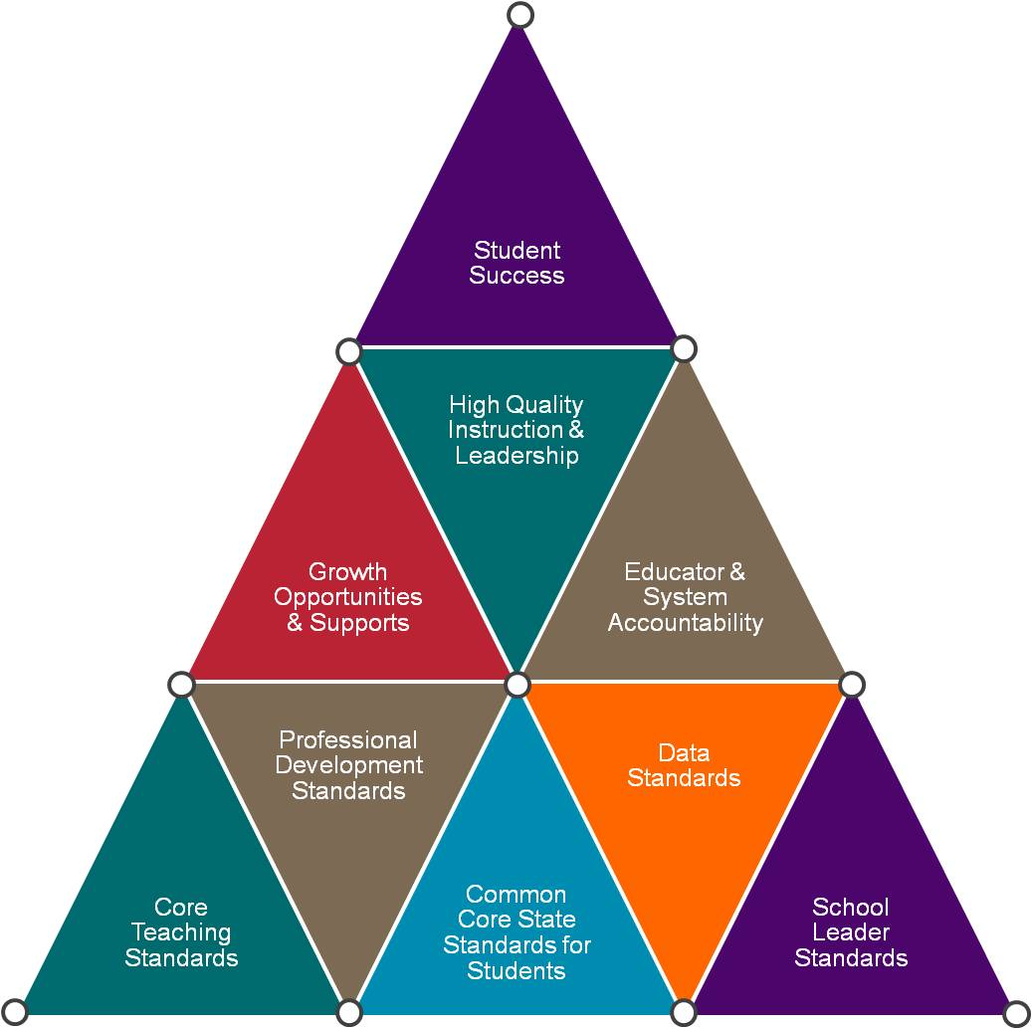

CCSSO’s Components of a High Quality Educator Development System

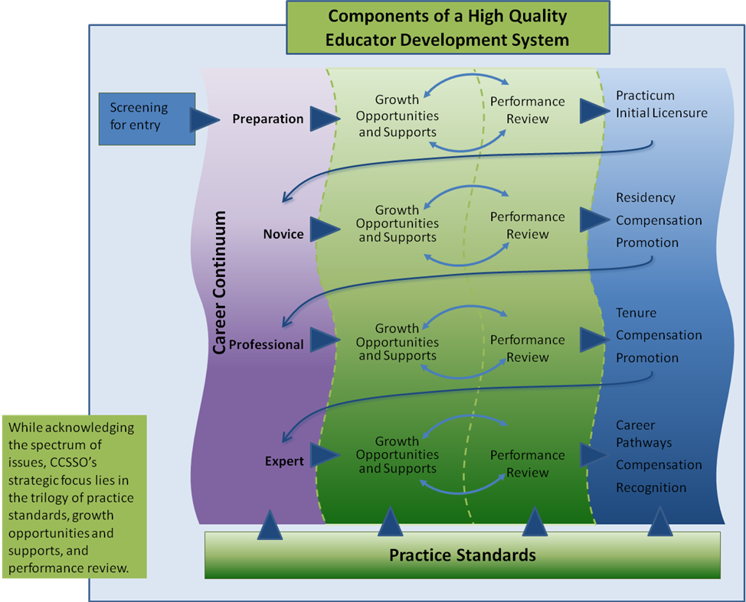

Bill and Melinda Gates Foundation’s MET Project

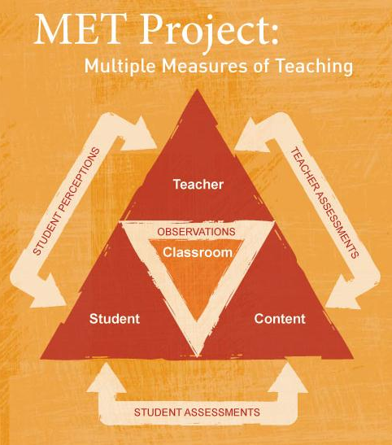

Does your state have a graphical representation of your educator effectiveness system? Upload documents to the SCEE site and we will add them to the next edition.

Theories of Change or Logic Models

Massachusetts

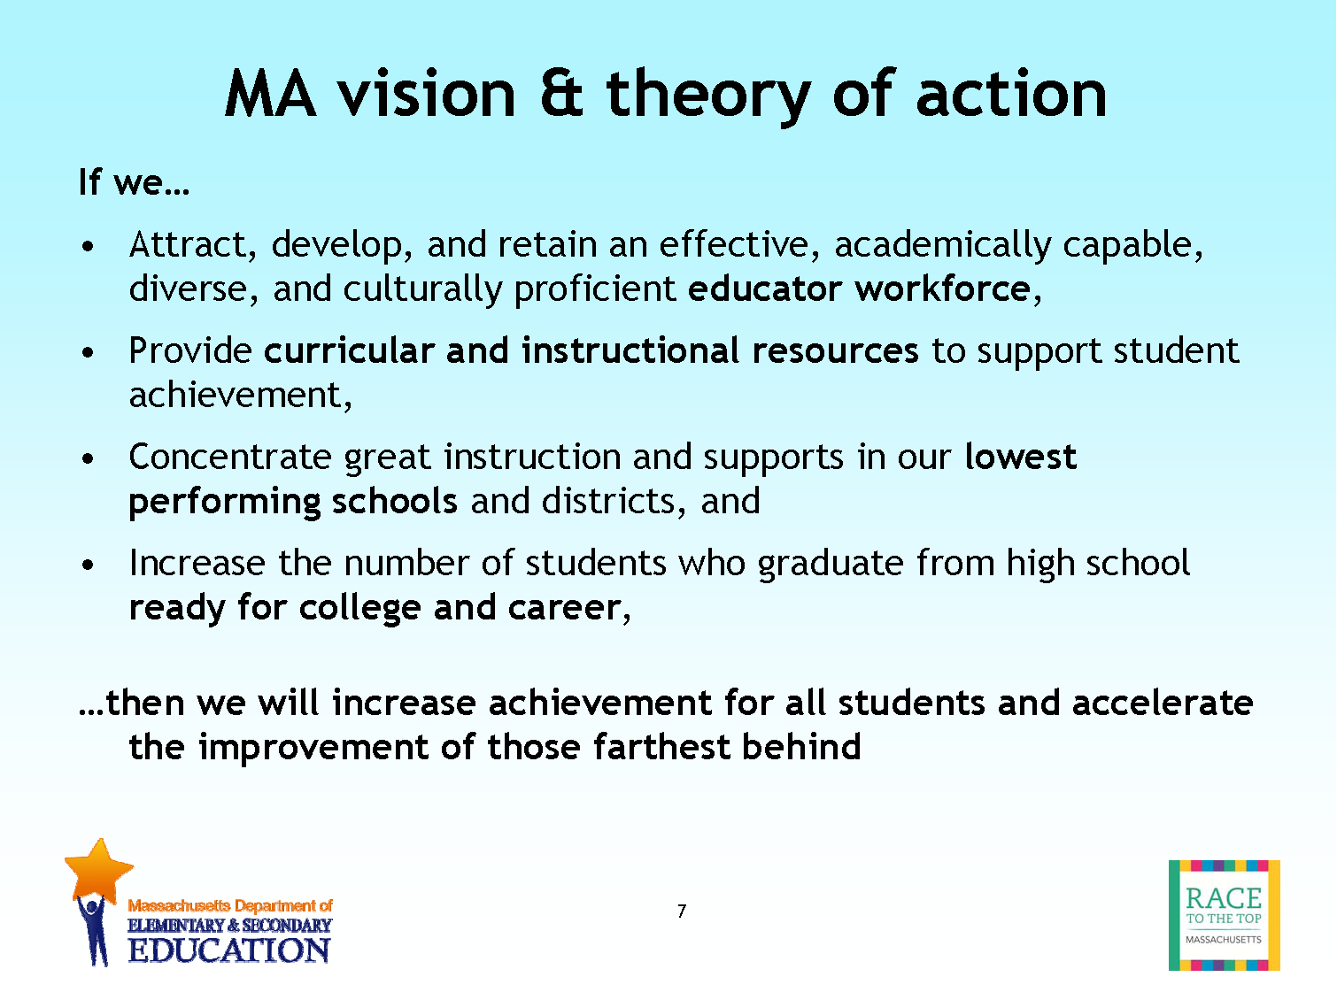

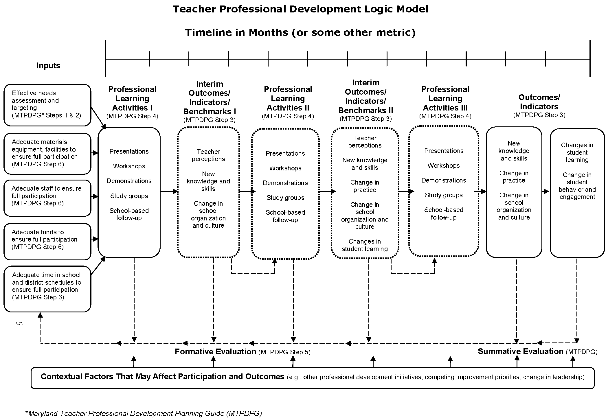
Maryland

Does your state have an articulated theory of change or logic model? Upload documents to the SCEE site and we will add them to the next edition.

Graphic Representations of System Relationships

Graphical representations can demonstrate system relationships, as well as a desired change in relationships. West Wind crafted this representation of current relationships in one system and the shift to a new way of organizing for educator effectiveness. The goal is transformation from the current system where the student is at the end of the chain to a system where the student is in the center of an interconnected system of supports and where the classroom is not necessarily the only locus of learning.

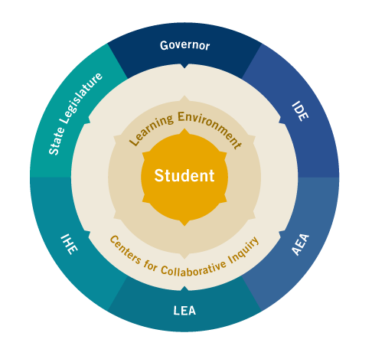

Does your state have a graphical representation of the relationships among the levels of your system (particularly as it relates to educator evaluation and support)? Upload documents to the SCEE site and we will add them to the next edition.

