For high school students to enter into a four-year university, they must pass state-required high school courses. For students who choose not to attend a university, the skills they earn in high school may not be the skills needed to succeed in a modern workforce. Creating more options like trade and technical schools can help students adapt to the workforce right after high school. Careers that include; welding, electricians, design, textiles, and so many more. Allowing for an education that helps guide students to successful and fulfilling careers will be at the top of Mark's agenda.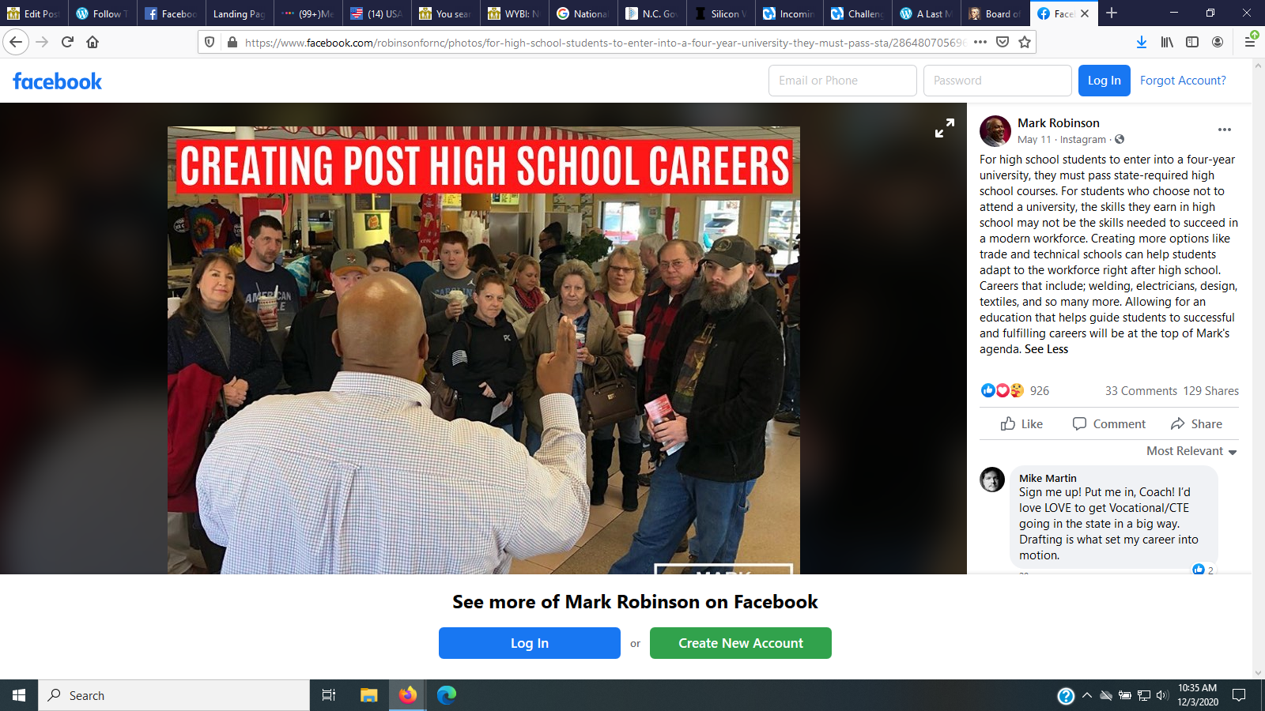
“For high school students to enter into a four-year university, they must pass state-required high school courses. For students who choose not to attend a university, the skills they earn in high school may not be the skills needed to succeed in a modern workforce. Creating more options like trade and technical schools can help students adapt to the workforce right after high school. Careers that include; welding, electricians, design, textiles, and so many more. Allowing for an education that helps guide students to successful and fulfilling careers will be at the top of Mark's agenda.” 5/11/20

